Lab experiment
3.Implementation of buffer management

Aim:
To write a C program to implement buffer management by accepting data from the user and displaying the data stored in the buffer, buffer size, and data size.

Explanation:
1.char buffer[100] allocates a buffer of 100 bytes.
2.fgets() reads the input from the user into the buffer.
3.strlen() calculates the length of the input string.
4.sizeof(buffer) returns the total buffer capacity, which is 100 bytes.
5.+1 includes the null terminator ('\0') in the data size.

Coding:

#include <stdio.h>
#include <stdlib.h>
#include <fcntl.h>
#include <unistd.h>

int main()
{
int source, destination; char buffer[100]; ssize_t bytes;

source = open("source.txt", O_RDONLY);

if (source < 0)
{
perror("Error opening source file"); return 1;
}

destination = open("destination.txt",
O_WRONLY | O_CREAT | O_TRUNC,
0644);

if (destination < 0)
{
perror("Error opening destination file");
close(source); return 1;
}

printf("File copy program\n");

while ((bytes = read(source, buffer, sizeof(buffer))) > 0)
{
ssize_t total = 0;

while (total < bytes)
{
ssize_t written = write(destination, buffer + total, bytes - total);
if (written < 0)
{ perror("Error writing file"); close(source); close(destination); return 1;
}
total += written;
}
}

if (bytes < 0)
{
perror("Error reading file"); close(source); close(destination); return 1;
}

close(source); close(destination);

printf("File copied successfully\n");

return 0;
}

Output:

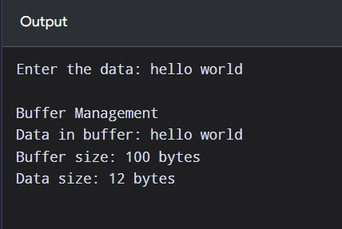

Result:
Thus, buffer management was implemented successfully in C by storing user input in a buffer and displaying the buffer contents, buffer capacity, and data size.

